1. **Write SQL Script to declare two numbers and print product of two numbers.**

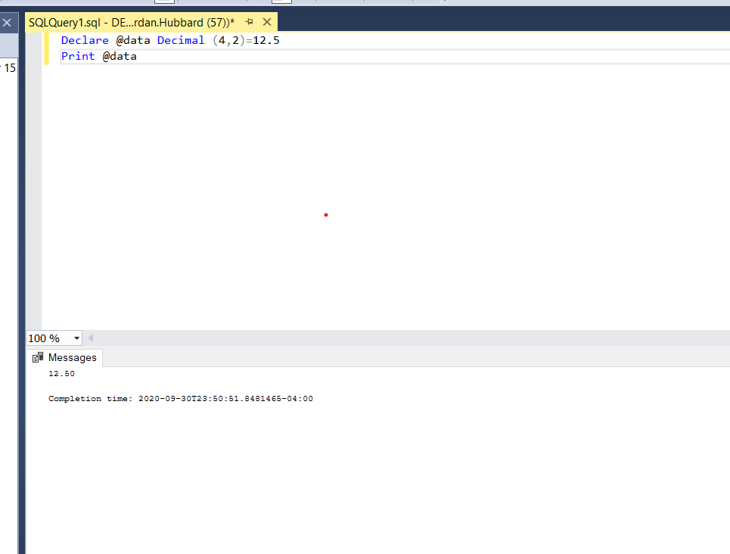

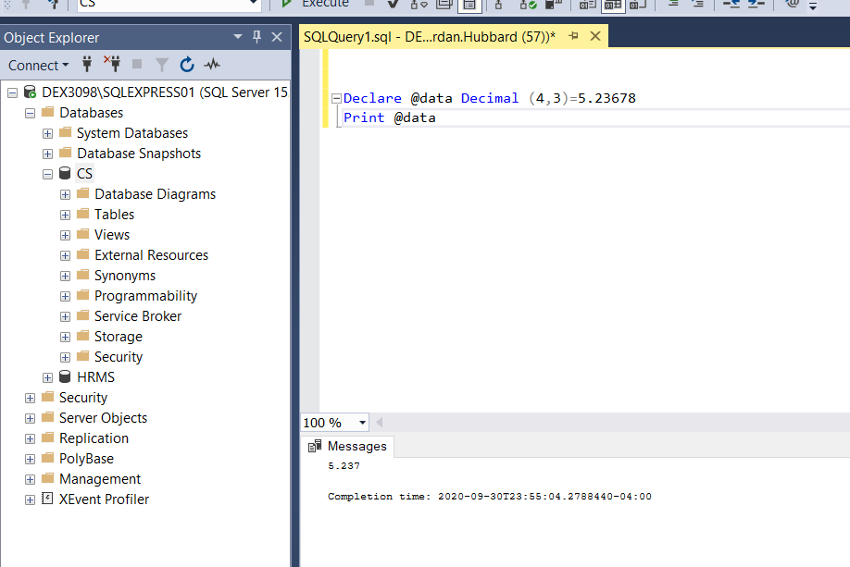

1. **Write the difference between Decimal and Numeric**.

Numeric determines the exact precision and scale while Decimal specifies only the exact scale.

1. **Research and write the difference between Float and Real.**

The main difference between Float and Real is that Real data can hold a value 4 bytes in size, meaning it has 7 digits of precision. While Float data can hold 8 bytes, or 15 places after the decimal point.

4. **Submit all data types we discussed in a tabular format.**

|  |  |  |  |  |  |  |  |
| --- | --- | --- | --- | --- | --- | --- | --- |
| **Data types for storing numbers** | **Data types for storing decimals** | **Data types for storing time** |  |  |  |  |  |
| Bit | Float | Date |  |  |  |  |  |
| TinyINT | Decimal | Smalldatetime |  |  |  |  |  |
| SmallINT | Real | Datetime |  |  |  |  |  |
| INT |  | Time |  |  |  |  |  |
| BigINT |  |  |  |  |  |  |  |
|  |  |  |  |  |  |  |  |
|  |  |  |  |  |  |  |  |